|  |
| --- |
| **Statement of Understanding - 1.3** |

Prepared: 19/06/2017

Updated: 04/10/2017

*Ref: E:\Projects\PROJECTS IN PROGRESS\SSDL\1. Documents\6. Quotes\KKM SSDL SOU 20170619 v1.3.docx*

Contents

Key Functional Requirements 4

AutoCAD 2018 Interface File Location 4

AutoCAD 2018 Interface File Location Configuration 4

AutoCAD 2018 Liva Nova Template 5

Existing Template 6

Proposed Template 7

Bill of Materials 7

Titleblock 7

AutoCAD 2018 Interface 8

Ribbon 9

Open Drawing Workflow 10

Open Drawing Interface 11

Find a Drawing 12

Open Symbol Library Workflow 13

Open Symbol Library Interface 14

Functions 15

Special Filters 15

Bill of Materials Workflow 17

Bill of Materials 18

Existing Bill of Materials 18

Proposed Bill of Materials 19

Generate BOM 20

Print BOM 22

Send BOM 22

Time Rollup Workflow 23

Time Rollup 24

Existing Table: PRODUCTS_RM 24

Table Design: 24

Data View: 25

Modified Table: PRODUCTS_RM 25

New Table: tblTime_Rollup_Categories 26

Design View: 26

Data View: 26

Generate Time Rollup 26

Print Time Rollup 27

Assumptions 28

A2K Technologies Deliverables – Excluded from Scope 28

Pre-Requisites 29

Hardware Requirements 29

Clarifications 29

Limitations 29

Appendix 30

Database Design 30

BOM Data Schema 30

# Key Functional Requirements

To develop an “AutoCAD 97 CCC” replacement incorporating best practices, whilst adhering to AutoCAD 2018 compliancy.

The current “AutoCAD 97 CCC” customisation has been in practice for some time, and with that, the “AutoCAD 97 CCC” shall be retired.

# AutoCAD 2018 Interface File Location

The associated application files will reside on the user’s local desktop as follows:

* C:\ACAD2018_LivaNova

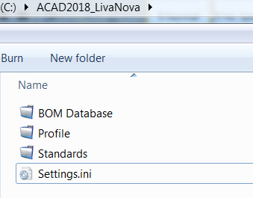

* BOM Database
* Profile
* Standards

## AutoCAD 2018 Interface File Location Configuration

The root folder “C:\ACAD2018_LivaNova” will contain a configuration file, called “Settings.ini”; with the following content.

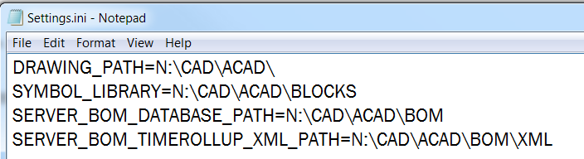

{SQL CONNECTION STRING}

*\*\* This folder will require read/write/execute permissions*

|  |  |
| --- | --- |
| DRAWING_PATH=N:\CAD\ACAD\ | Determines the location of all production drawings |
| SYMBOL_LIBRARY=N:\CAD\ACAD\BLOCKS | Determines the location of all Symbology (block libraries) |
| SERVER_BOM_DATABASE_PATH=N:\CAD\ACAD\BOM | Determines the location of the BOMData.mdb |
| SERVER_BOM_TIMEROLLUP_XML_PATH=N:\CAD\ACAD\BOM\XML | Determines the location of where resulting XML files will be saved. |

# AutoCAD 2018 Liva Nova Template

The Liva Nova template (standards drawing) will reside in the folder:

**C:\ACAD2018_LivaNova\Standards**

This standard drawing will be called **LIVA NOVA TEMPLATE.dwt**

## Existing Template

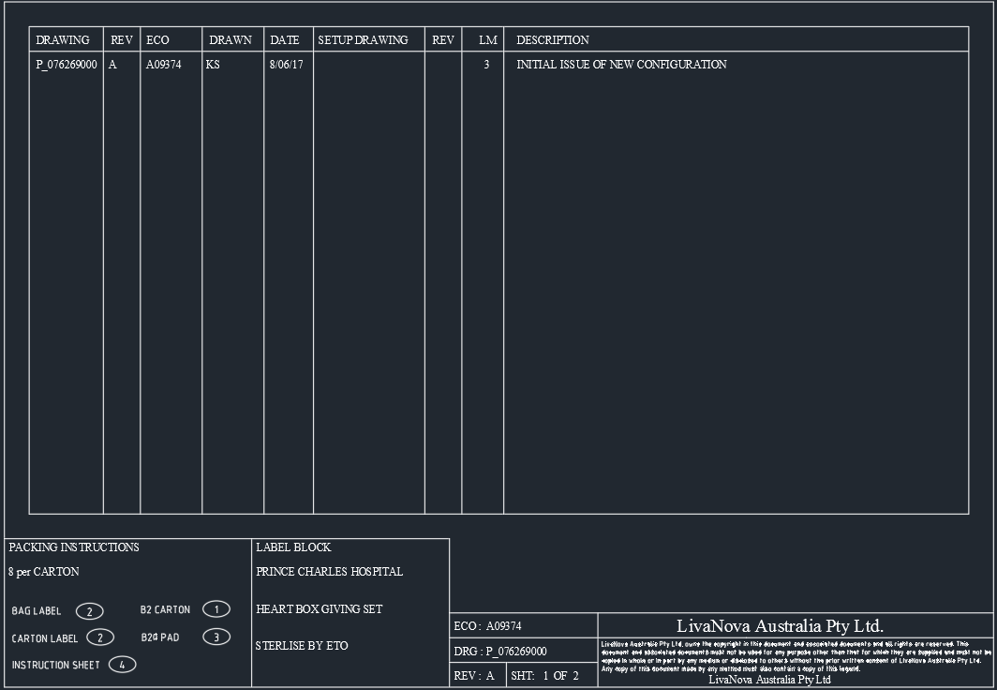

*\*\* Images are for illustration purposes only and are not drawn to scale.*

Key Notes:

* The existing template does not use an AutoCAD compliant table for BOM data entry. Subsequently, the BOM table is made up of a series of lines and multiline text, making it cumbersome to modify.
* The “Packing Instructions” consist of multiple blocks, which require the user to edit each. This can be simplified, by attributing these within the Titleblock *(The same also applies to the “Label’ Block”).*

## Proposed Template

### Bill of Materials

Below is an example of the proposed Bill of Materials. This table is AutoCAD Compliant and can consist of colour schemes, sorting mechanisms, cell resizing, calculated fields and other functions.

All data entry can be constrained to the data type, i.e, integer for numbers (LM), date/time for date (DATE) data entry etc…

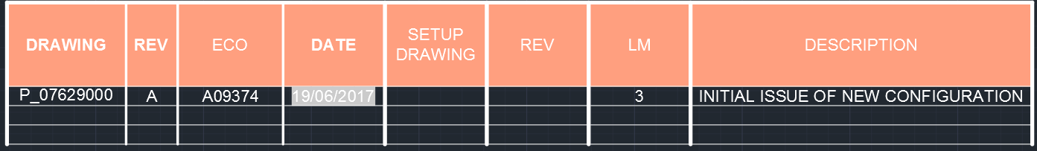

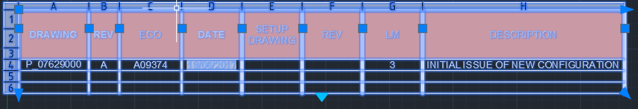

The BOM Table will be created from the BOM data base/ blocks found in the drawing and not written manually in the DWG. The above table can be plotted where applicable.

### Titleblock

Below is a conceptual example of a Titleblock, with a few suggestions.

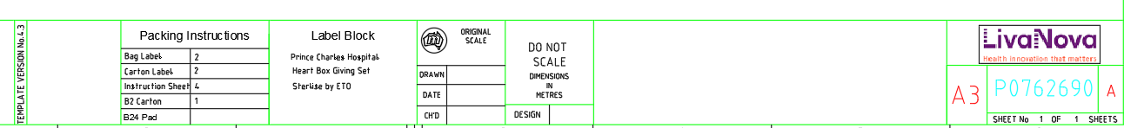

*\*\* Images are for illustration purposes only and are not drawn to scale.*

**Suggestions:**

* Add the Date when the design was drawn
* Add the Designer’s name or initials
* Add (include) the Time Rollup
* Add disclaimer – “Drawing not to scale”
* Packing Instructions to be attributed to include:
  + Bag Label
  + Carton Label
  + Instruction Sheet
  + B2 Carton
  + B24 Pad
* Label Block to be attributed to allow free-hand text entry

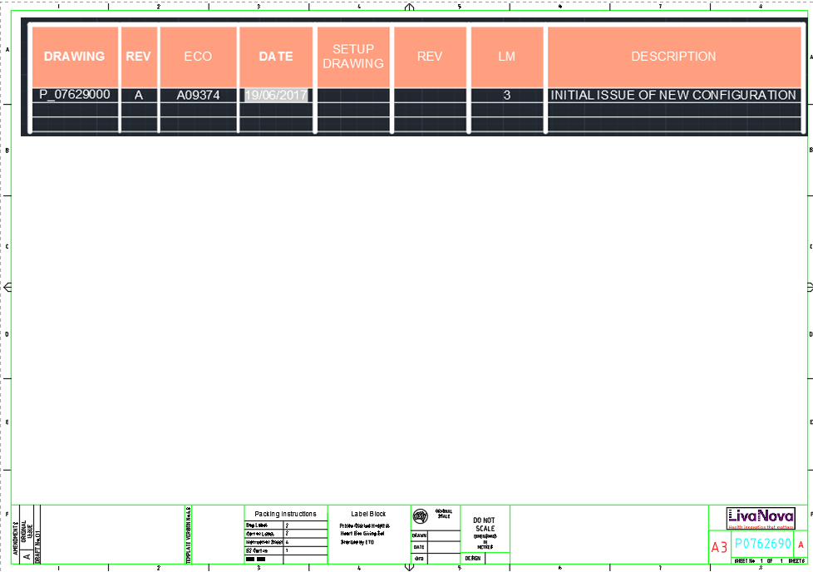

*\*\* Images are for illustration purposes only and are not drawn to scale. Colours and design are indicative only.*

# AutoCAD 2018 Interface

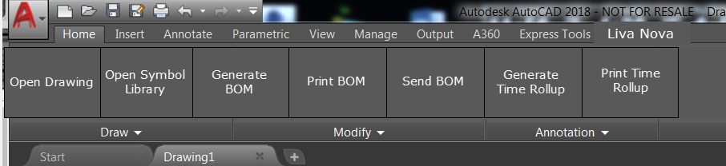

*\*\* Images are for illustration purposes only and are not drawn to scale.*

## Ribbon

An AutoCAD 2018 compliant Ribbon (*shown above*) will be created under the menu heading “Liva Nova”, with the customised feature functionality as outlined below:

* Open Drawing
* Open Symbol Library
* Generate BOM
* Print BOM
* Send BOM
* Generate Time Rollup
* Print Time Rollup

The workflows and associated functionality is outlined below.

## Open Drawing Workflow

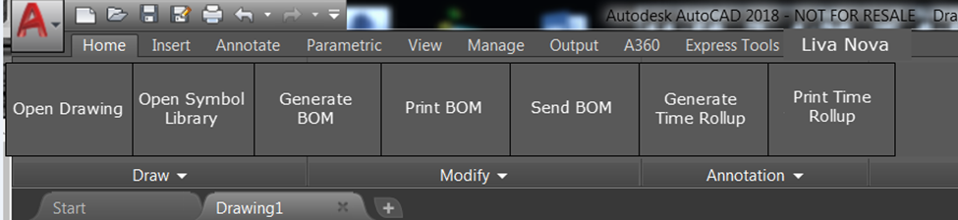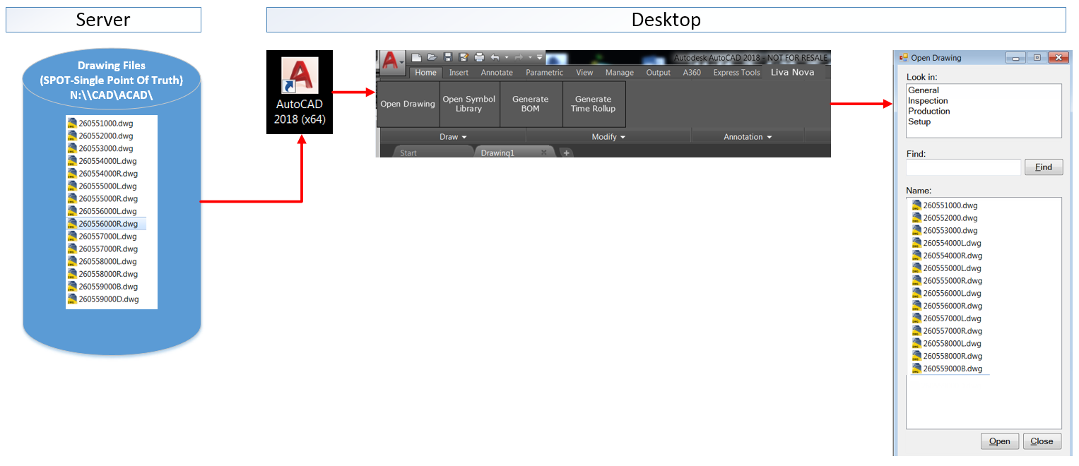

The above will be developed in a .NET environment

*\*\* Images are for illustration purposes only and are not drawn to scale.*

How To:

* Open AutoCAD 2018
* Select the “Open Drawing” button
* Navigate and select required drawing
* Note: The user can still elect to use the standard AutoCAD “Open” command if they wish.

## Open Drawing Interface

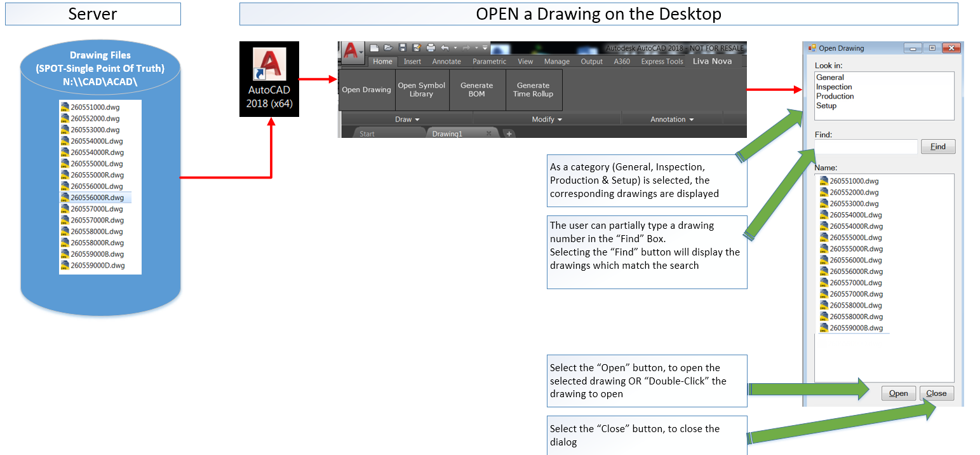

*\*\* Images are for illustration purposes only and are not drawn to scale.*

How To:

* Select a category from the “Look in” window
* When a category is selected, all drawing files are listed
* The user can further refine their search by entering a partial drawing number, followed by the “Find” button

## Find a Drawing

|  |  |
| --- | --- |
|  | * The Open Drawing dialog will default to the pre-defined file location, as specified in the Settings.ini (“Drawing_Path”) * By Default, this will display the current folders (General, Inspection, Production and Setup)   User Steps:   * The user will select a Category General, Inspection, Production and Setup * The associated drawings which exist in the selected category are displayed   Find:   * Navigate through the list of drawings, and select a drawing which should be opened   OR   * The user can execute the “Find” function, by typing a partial drawing number, selected by the “Find” button.   Open:   * The user can select the “Open” button to open a selected drawing, or “double-click” the selected drawing |

*\*\* Images are for illustration purposes only and are not drawn to scale.*

## Open Symbol Library Workflow

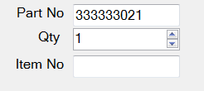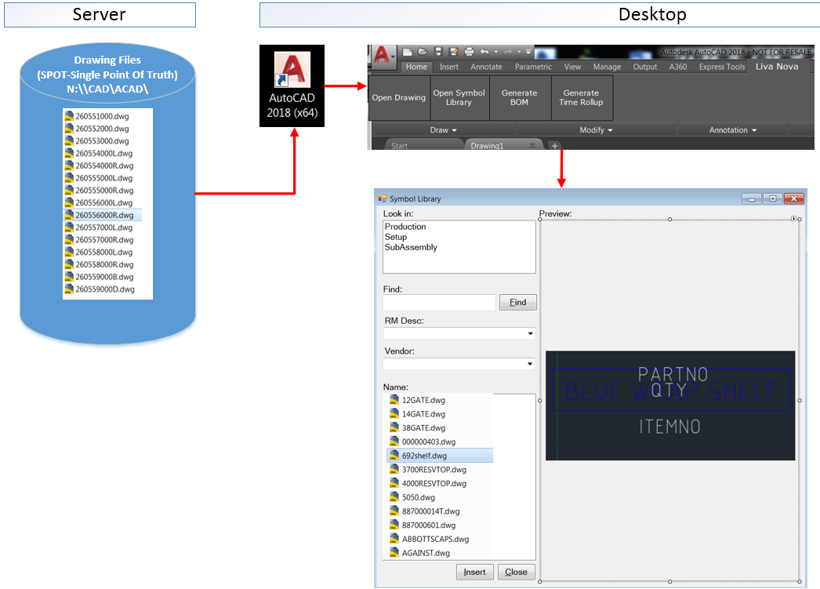

This interface will be developed in a .NET environment

*\*\* Images are for illustration purposes only and are not drawn to scale.*

## Open Symbol Library Interface

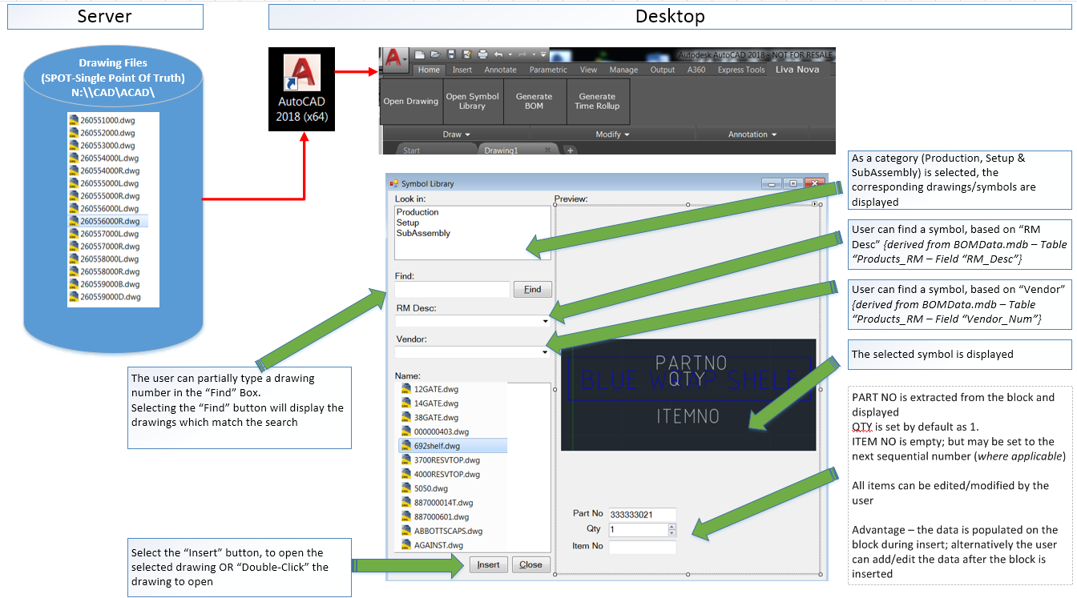

*\*\* Images are for illustration purposes only and are not drawn to scale.*

## Functions

* Blocks are automatically listed, based upon the category selection of “Production”, “Setup” and “Sub-Assembly”
* Users can narrow their search via the options, “Find”, “RM Desc” and “Vendor”
* When a block is selected from the “Name” list, a graphical preview will be displayed to the user.
* Any available data *(including Part No, Qty and Item No)* will be extracted and displayed on-screen for the user to modify (*if they wish*) prior to insertion.
  + Note: Part No, Qty and Item No can also be modified after the block is inserted.

## Special Filters

“RM Desc” and “Vendor” are derived from the BOMData.mdb database, specifically the PRODUCTS_RM table.

|  |  |
| --- | --- |
| **RM_Desc** | **Vendor** |
|  |  |

The left-most field should relate to the drawing, located in THE (SYMBOL_LIBRARY) N:\CAD\ACAD\BLOCKS, that is, for example, “000000002.dwg” should exist as a symbol drawing in N:\CAD\ACAD\BLOCKS.

In summary, this extends the search feature, to allow searching based on Number, RM_Desc and Vendor.

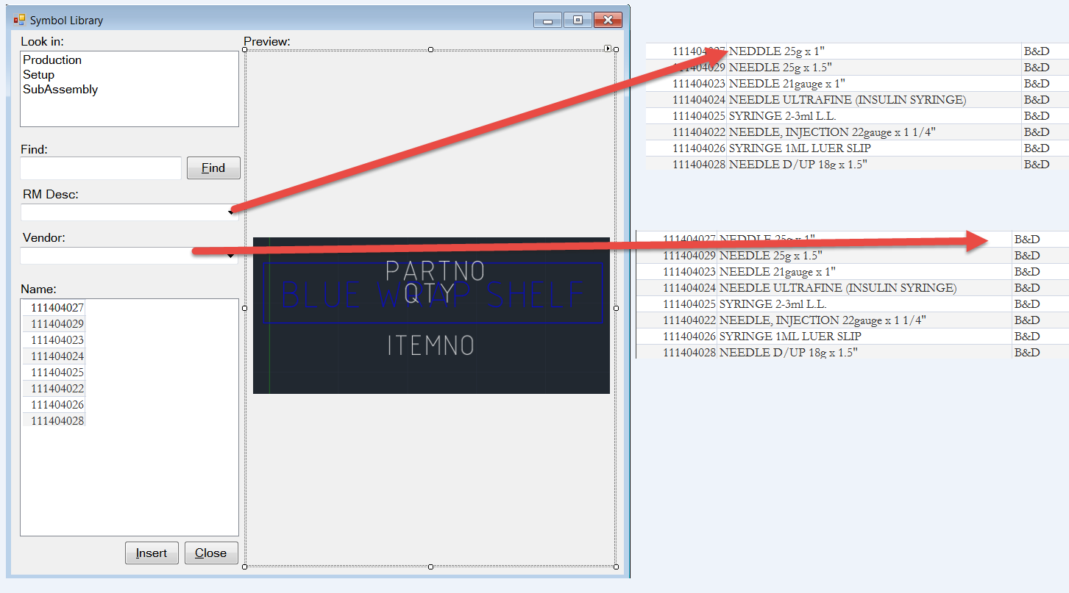

*\*\* Images are for illustration purposes only and are not drawn to scale.*

# Bill of Materials Workflow

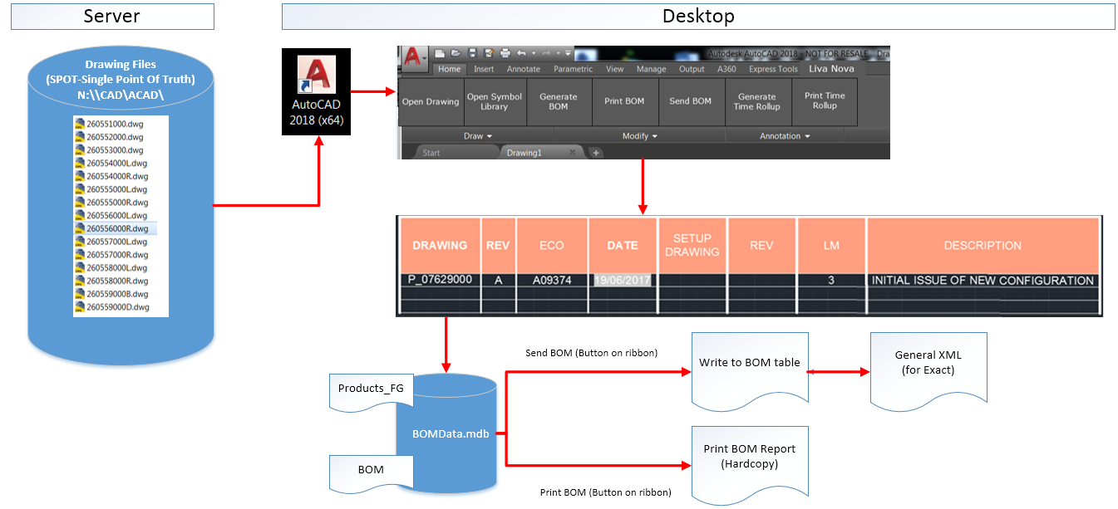

This will be developed in a .NET environment

*\*\* Images are for illustration purposes only and are not drawn to scale.*

# Bill of Materials

## Existing Bill of Materials

The existing Bill of Materials is shown below. This is made up of a series of lines and multi-line text, without any CAD intelligence.

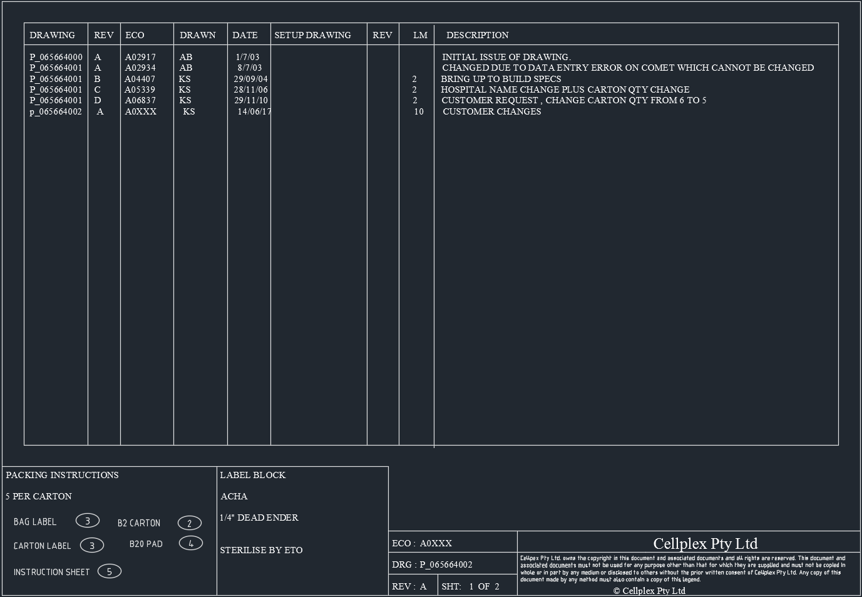

Example Drawing: *P_065664002.dwg*

*\*\* Images are for illustration purposes only and are not drawn to scale.*

## Proposed Bill of Materials

Below is a proposed Bill of Materials which is AutoCAD compliant, using the same drawing sample as above.

The formatting of the table below can be configured, and can include formulae (*specifically for the summation of LM*), as well as data types such as date/time.

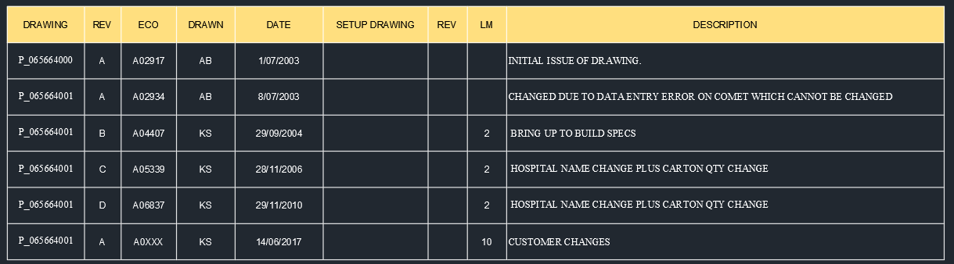

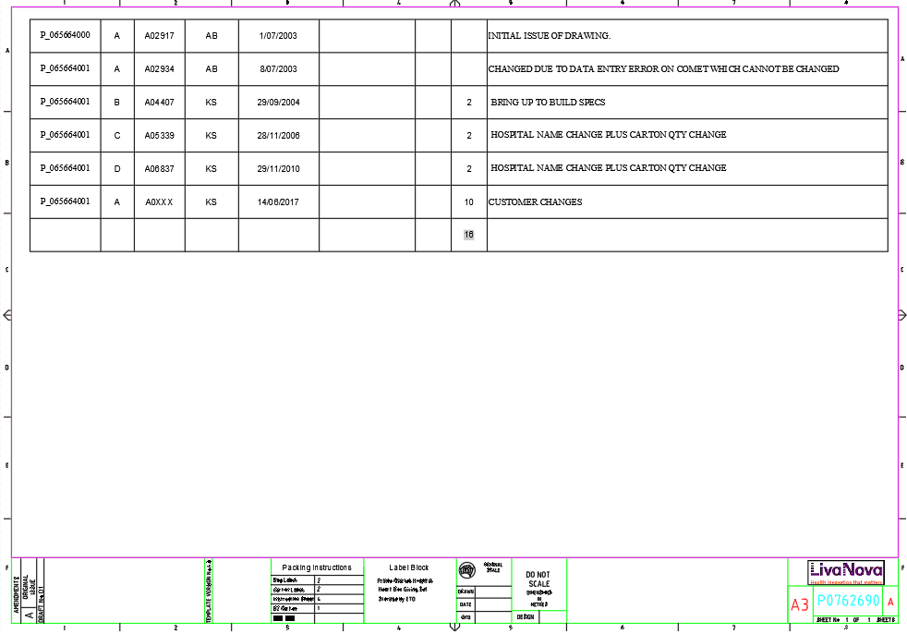

*\*\* Images are for illustration purposes only and are not drawn to scale.*

The Bill of Materials incorporates the following functions:

* Generate BOM
* Print BOM
* Send BOM

### Generate BOM

Selection of the “Generate BOM” button will scan the drawing, reading each “Component” block. As each “Component” block is read, the “Qty”, “Item No” and “Part No” are extracted to create the Bill of Materials.

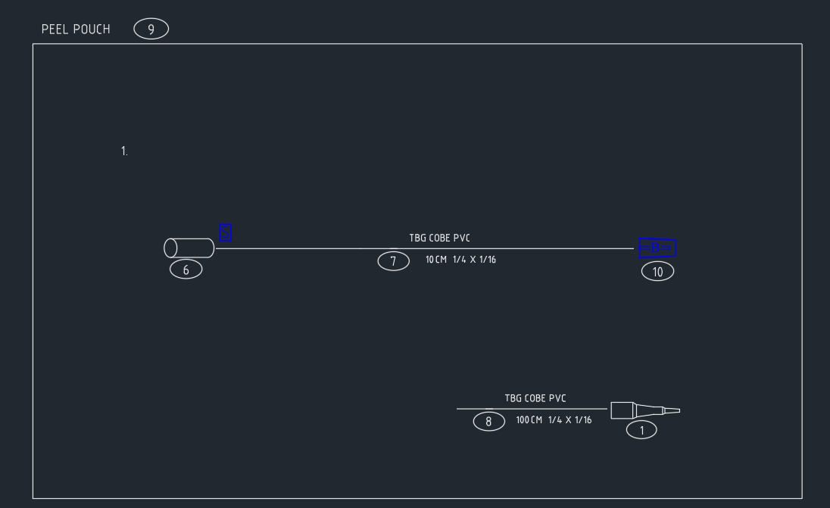

Example Drawing: *P_065664002.dwg*

A secondary scan is executed on the Titleblock to read each “Item” block

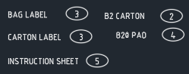

*\*\* Images are for illustration purposes only and are not drawn to scale.*

* Blocks 1, 6, 7, 8 and 10 are components and are derived from the table Products_RM
* Blocks 2, 3, 4 and 5 are Items and are derived from the table Products_RM

Each block, contains the attributes:

* ItemNo
* PartNo
* Qty

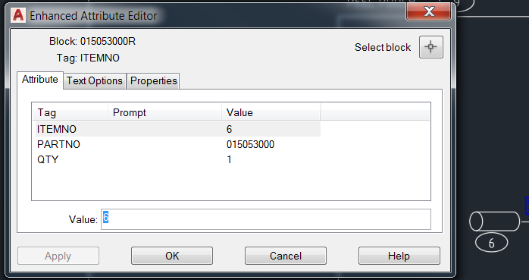

These attributes are used to populate the Bill of Materials

In the above example, ITEMNO of 6, refers to line 6 of the BOM. PARTNO of 015053000 is referenced in the table “Products_RM”, and is used to derive the description.

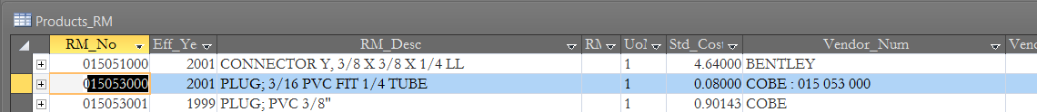

Refer to ITEMNO 6 below

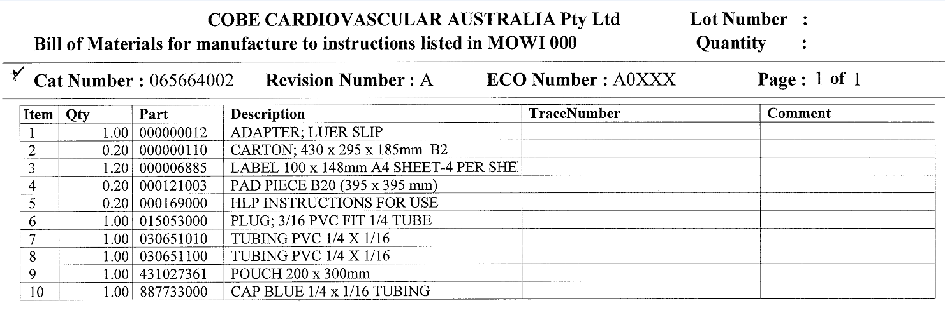

### Print BOM

The “Print BOM” function will output a hardcopy of the Bill of Materials as shown above.

**Note:**

* The format and/or template document used to create the above output is required.

### Send BOM

The “Send BOM” function will update the “BOM” data table within “BOMData.mdb” and create an XML Compliant file to be imported into Exact.

**Note:**

* An XML will be provided. However, the import of the XML file is the responsibility of Exact resources.
* The format of the XML must be provided by Exact resources.

# Time Rollup Workflow

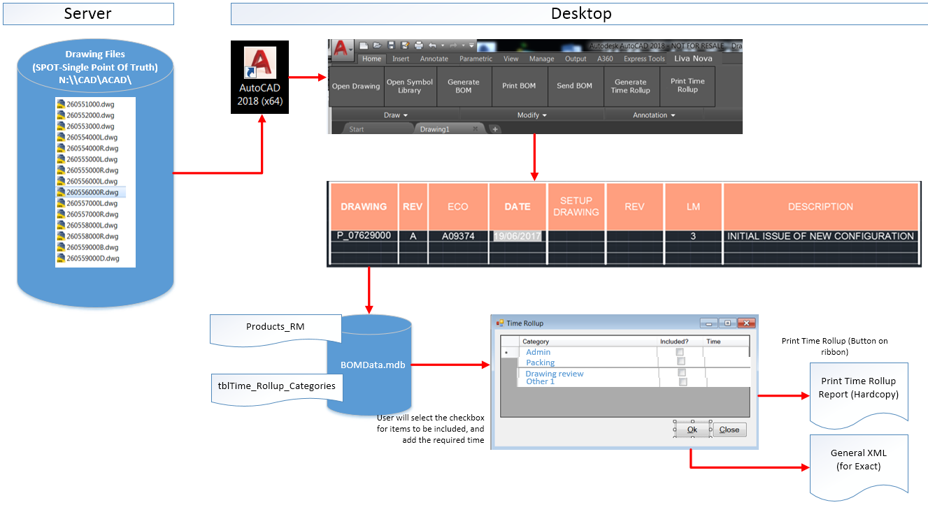

This will be developed in a .NET environment

*\*\* Images are for illustration purposes only and are not drawn to scale.*

# Time Rollup

The Time Rollup incorporates the following functions:

* Generate Time Rollup
* Print Time Rollup

The BOMdata.mdb database will be modified to cater for Time Rollup, which will include, editing of the table **PRODUCTS_RM**, to include a data field for “Time Rollup”, as well as a new table for each Category (*Admin Time, Packing Time, etc.…*)

* Products_RM
* tblTime_Rollup_Categories

## Existing Table: PRODUCTS_RM

### Table Design:

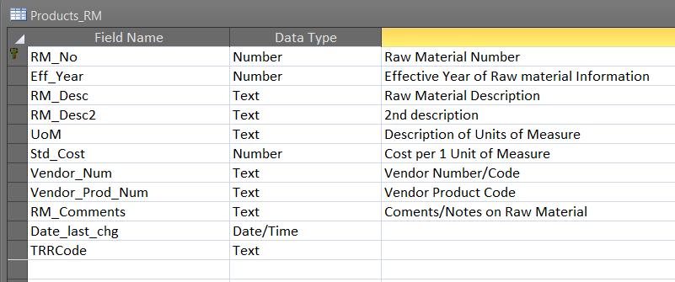

### 

### Data View:

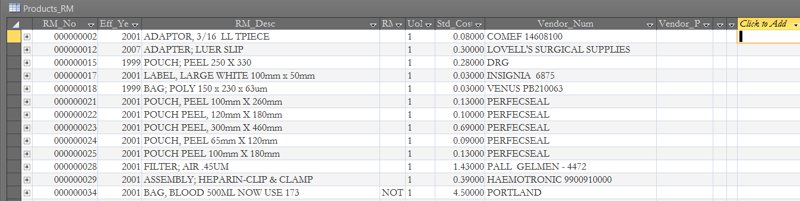

## Modified Table: PRODUCTS_RM

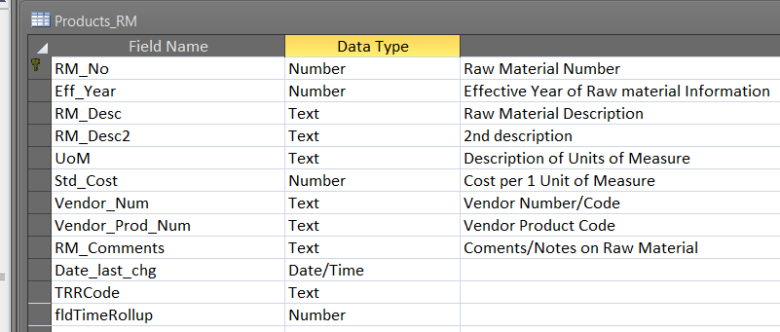

New field added – “fldTimeRollup”

Additional field to be added to cater for Time Rollup.

**Note:**

* The client will require input of “Time Rollup” for each of the components. The input for “Time Rollup” is the responsibility of the client.

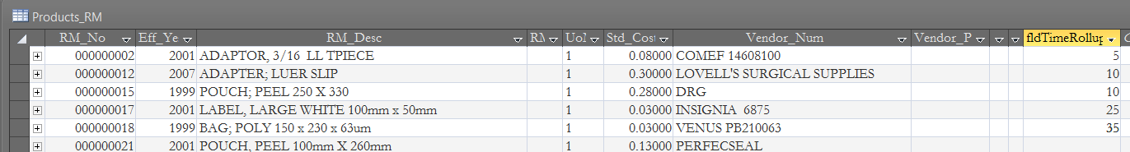

Each component will be allocated a time entry

## New Table: tblTime_Rollup_Categories

### Design View:

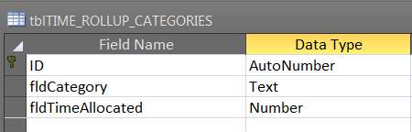

### Data View:

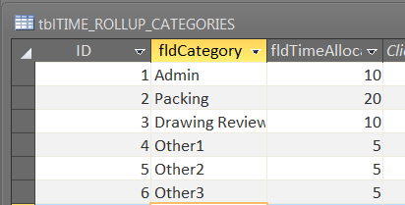

**Note:**

* A list of categories, with their associated time elements will be required to populate the SQL database.

### 

### Generate Time Rollup

The “Generate Time Rollup” function will calculate the total time, including the time allocated against components, as well as time allocated against Categories.

The output will be an XML file, to be consumed by Exact.

Prior to the creation of the XML file, the user will be required to “check” the categories, and enter the applicable time component.

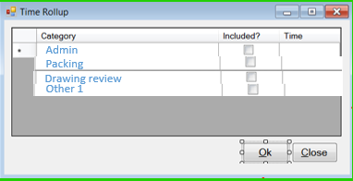

*\*\* Images are for illustration purposes only and are not drawn to scale.*

### Print Time Rollup

The “Print Time Rollup” function will output a report as a hardcopy. The format of this report is yet to be defined.

**Note:**

* The client will be required to provide a list of “Categories”, with their respective time elements.
* The importing of the XML file into Exact is the responsibility of Exact resources.
* The format of the XML must be provided by Exact resources.

## 

## Assumptions

A2K Technologies make the following assumptions:

* All Block Libraries/Symbology will be verified and checked for accuracy by the client.
* Block Libraries and Symbology is the responsibility of the client.
* No blocks shall be added, edited or deleted by A2K Technologies.
* All data stored in the MS Access database shall be exported to the SQL Server environment. The accuracy of the data is the responsibility of the client.
* All existing drawings and their associated content is the responsibility of the client.
* A2K Technologies shall provide all CUIX files to include menus/toolbars/ribbons (*i.e., the associated mnr/mnl files*).
* A2K Technologies shall provide an installation package electronically.
* A2K Technologies shall provide an XML file for the purposes of importing into Exact. The importing of the XML into Exact, is the responsibility of Exact resources, and Exact resources shall provide the required format of the XML file.
* Exact have the responsbility of importing the XML file into the environment.
* A2K Technologies shall provide up to SIX (6) Help Videos
* The client will perform the task of data entry on the table Products_RM, to include the “time rollup” for each of the 1375 components.
* The client will provide the template/format to be used for the output of the Bill of Materials hardcopy.
* The client will provide access to the SQL Server environment for the purposes of importing the MS Access data
* Any product procurement (*including, but not limited to AutoCAD Licences, SQL Server seats etc…*), where applicable, is excluded.
* Exact will be responsible for the supply of any XML schema’s and/or requirements.
* Exact will be responsible for reading the XML file and importing this into the Exact environment.

# A2K Technologies Deliverables – Excluded from Scope

A2K Technologies shall not modify, develop and/or provide support for the following artefacts:

* Existing production drawings
* Existing block libraries
* Existing MS Access Database

# 

# Pre-Requisites

* AutoCAD 2018 (*64-bit*)
  + *(No support for 32-bit environments)*
  + *(No support for AutoCAD 1997 LT)*
* Windows 7 (*64-bit*) or later
* SQL Server 2008 R2 (*or later*)

# Hardware Requirements

* Refer to the Autodesk website for hardware and graphic card requirements

# Clarifications

* To be determined (*where applicable*) upon project commencement

# Limitations

* To be determined (*where applicable*) upon project commencement

# 

# Appendix

## Database Design

### BOM Data Schema

* Below is a summary of the BOM Data Schema, with relevant Primary Key fields. The database exists in MS Access format.

|  |
| --- |
|  |